AntennaPod-4548

ID-274

Apk

2.0.1

Bug report description

<https://github.com/AntennaPod/AntennaPod/issues/4548>

**Steps to reproduce**:

1. Download an episode of any podcast
2. Go to the list of episodes, filter on « Downloaded »
3. Notice the list is correctly filtered to the downloaded episode
4. Long press the episode and choose « Delete ».

**Expected behaviour**:  
The deleted episode should be removed live from the list filtered on « Downloaded ».

**Current behaviour**:  
The episode stays in the view although it’s not downloaded anymore.  
It requires applying the filter again for the view to update.

**First occurred**: This is a regression of 2.0.1 vs. the 1.8.x series

Screen shots sequence

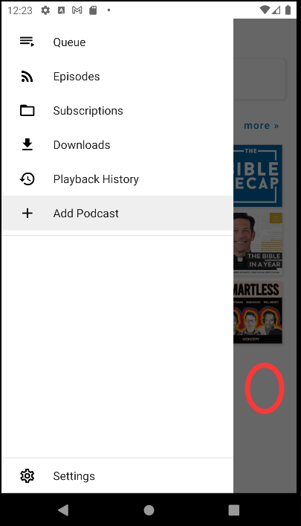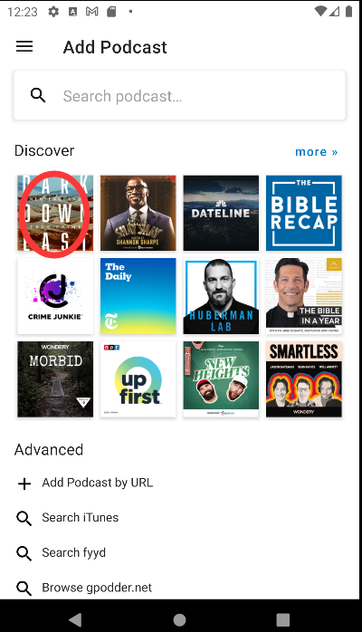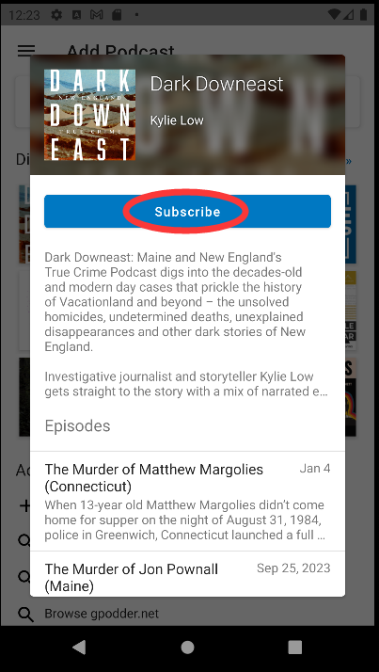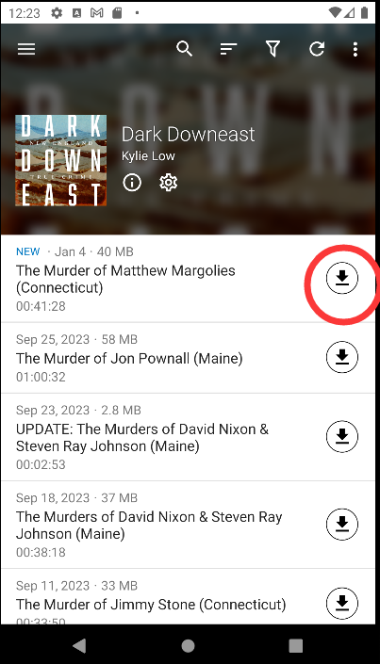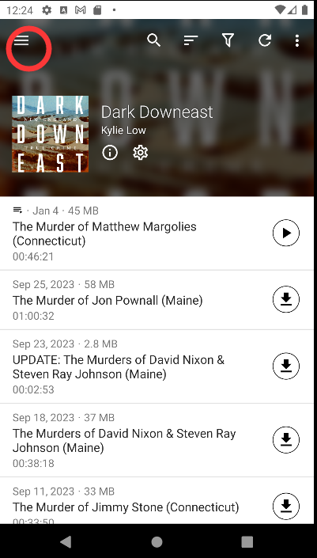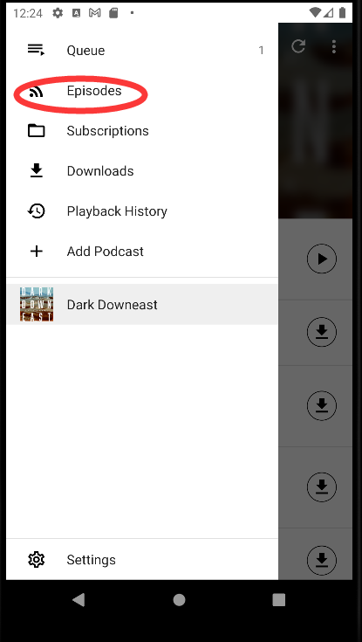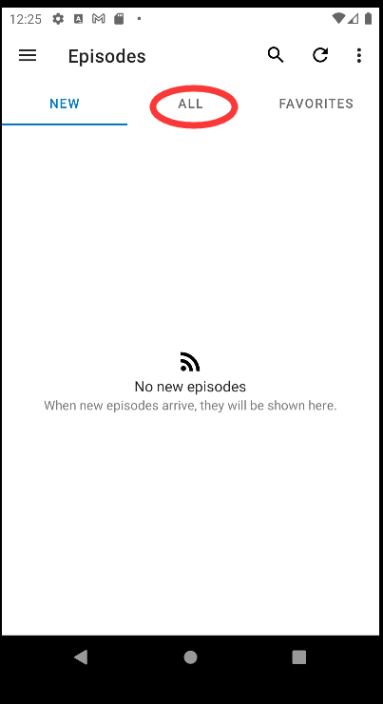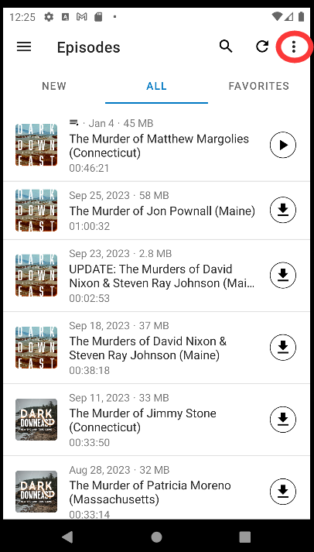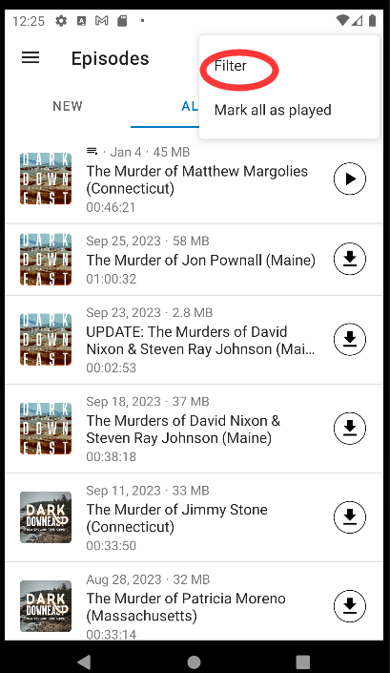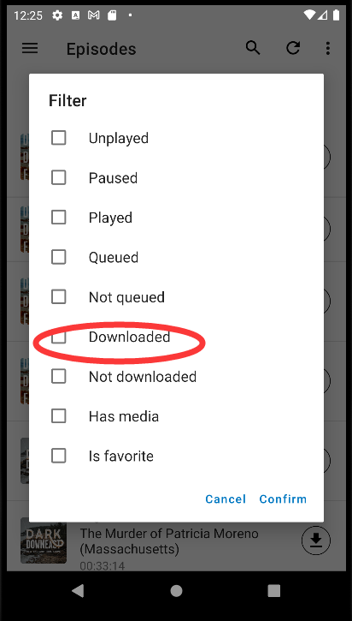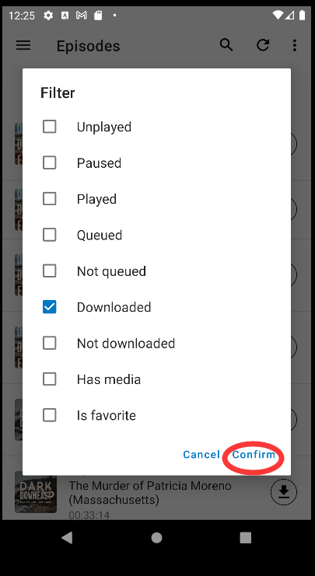

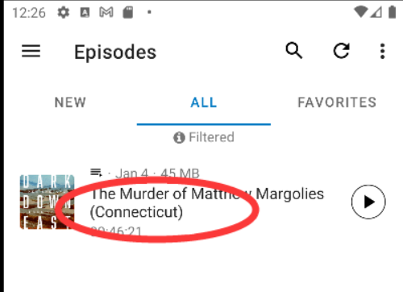

*click the episode name, then click delete, then click back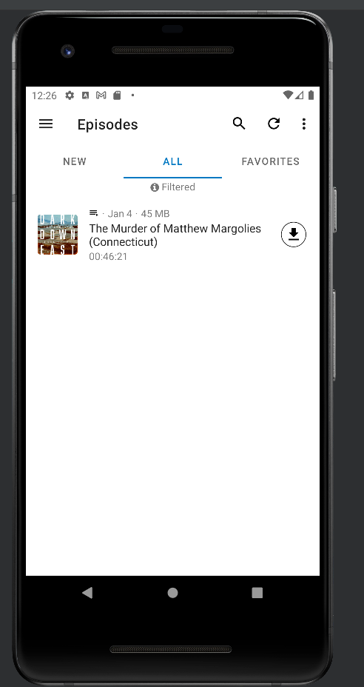Notice that the episode is already deleted, but still show up in the downloaded filter. When you apply the filter again, it will disappear.